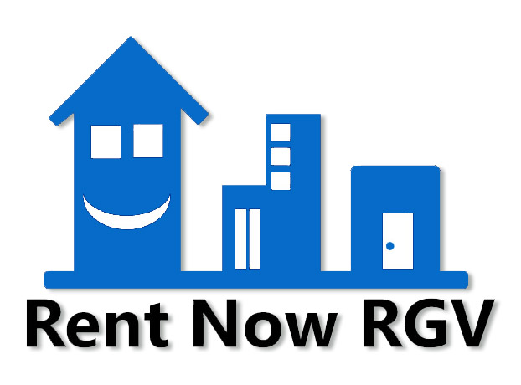TENANT SCREENING CRITERIA
The screening process can move quickly—between 24-48 hours from a new applicant to a decision. At Rent Now RGV we have developed a standard criteria for what to look for in an excellent tenant.
See the following helpful checklist to screen all applicants fairly while using the same standards for everyone.
Every tenant screening process starts by collecting applicants. To avoid discrimination, whatever criteria Rent Now RGV sets needs to be applied equally to all tenants. We include these requirements:

All applicants will be required to pay a $60.00 application fee
Minimum monthly income is 3x the monthly rent personal or combined with another occupant
Proof of income: Last 2 months of check stubs, Two months of bank statements (latest), Tax Return, Letter from employment, Employment contract, Social Security letter or void check, direct deposit statements, Disability Income Letter, Housing Voucher.
Minimum time at current employer 3 months
Co-Signing of a third party who will sign the contract is available with same requirements by applicant if not enough income is provided.
For section 8 units a pre-approval of current market rate by inspector or case worker is required as rental prices will not be adjusted and some units may not comply with program requisites.
Relocations and new employment will require a letter or formal contract agreement of employment by employer stating the salary or hourly rate and hour expected.
Criminal record check, a tenant will not qualify if record shows: Sexual Offenses, Larceny, Homicide or any other felony that is a prior relevant conviction indicate the applicant could put the building or neighborhood at risk.
By applying in person, online or with pre-qualification form you confirm consent for a background check.
All tenants and occupants must fill in an application form, either online or in person or by email.
Details to be filled out include: Name, Contact Info, Employment, Income Rental History References, Employment history, Emergency contact numbers, DL & Social among others.
We will look for bankruptcies or delinquencies and may check credit score.
Check employment history: Confirm a consistent history of employment and current employment.
Check rental history: Frequent address changes or a history of evictions will rule you out as a tenant.
We may contact prior landlords to confirm past residences. Ask landlords if there were problems, how the tenant left the property, or if they would rent to this tenant again.
WE DO NOT REJECT anyone based on race, disabilities, or anything that violates the Fair Housing Act (FHA) or Americans with Disabilities Act (ADA). RENT NOW RGV is proud to have tenants of all races, ages and background as well as members of the LGBT community, senior occupants, professionals, Law enforcement, Members of the medical community, HUD tenants, Section 8 and families with children.
You will receive an email, notification on tenant’s portal, text or call to notify you if your application is complete and if it passed criteria to be able to move in!
Finalize the Lease Agreement Online or in Person.
Review all policies and procedures, including when rent is due, late fees, how to request maintenance, seasonal inspection policies, what to do in an emergency, and more.
Provide your own the Move-In inspection within 3 days of move in, include photos if needed on your tenant portal or at management@rentnowrgv.com
For repairs and service calls use your tenant portal or email management@rentnowrgv.com
Welcome to your new home!

www.RentNowRGV.com
956 627 5506 Ext 1
Text or WhatsApp: 956 432 9507
info@rentnowrgv.com

